# What is Looker

Google Cloud BI Tool

Developer environment (LOOKML)

Explorer (End user environment)

# Features Summary

* Browser-based tool that offers a unique modeling language. No need of any local designer installation
* Onprem and Cloud based
* SQL based relational connections
* GIT Version control and Integration to support CI/CD process
* Customizable visualtion using JSP and D3
* across AWS, Azure, Google cloud, and on-premise databases.
* Bring data to us and not us going to the application
* Alert through email if key KPI doesn’t meet threshold
* Sharing, Email capability
* Export options
* Tools : marketplace, SQL Runner, data group, color collections
* Cache of same query is available in Looker end after pulling data into Looker(cache timelimit can be setup)
* SQL RUNNER Is quick way to setup live connection to datasource and access table and join them
* Folders are available to save dashboard and looks
* Looker IDE doesn’t have compiler or Integrator. It as auto suggestion,context sensitive help

# Position in Gartner BI quadrant (2021)

* 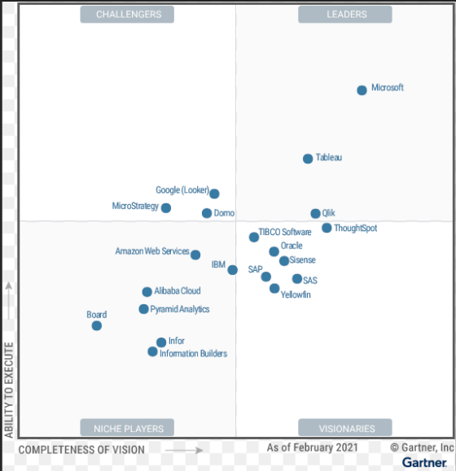

# End user reporting

**Single data visualization:**

* This is a tile visualization
* It always picks first rows in a table and displays single value is used
* If no measure is used, it takes dimension as second priority
* If two measure are used, it takes first measure in big display and shows second measure for comparison in the lower bottom

**Single record visualization:**

-one record is converted from row to “Field name” :”value” format for display

**FEatures**

1. Merge results of multiple looks
2. “Run on Load” same as “refresh on open” in BOBJ
3. Use “Develop” mode on bottom right to switch to edit the LOOKML model

# Model

## Look of model(develop mode)

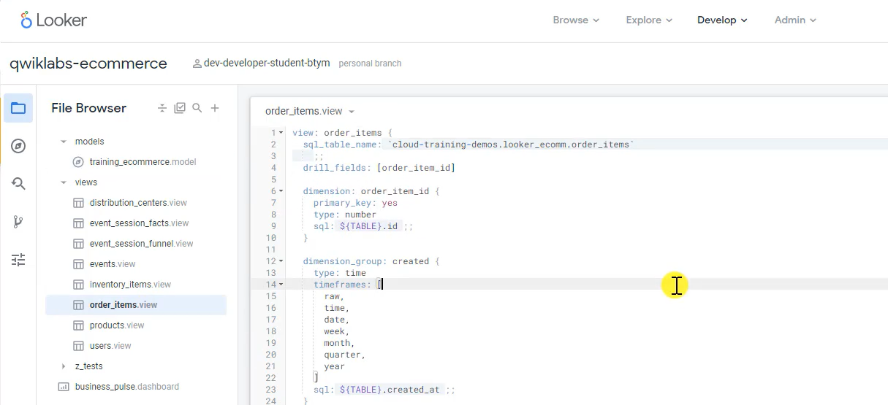

## Dimension Types

**String**

**Time**

**Number**

## FILE Types

* View
* Model
* Explore
* Manifest
* Markdown (MD)

## Screenshot of model:

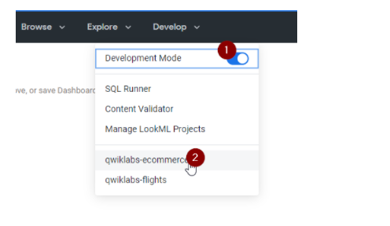

name of the Model is mentioned in label

Two explores and each of them has many views and join

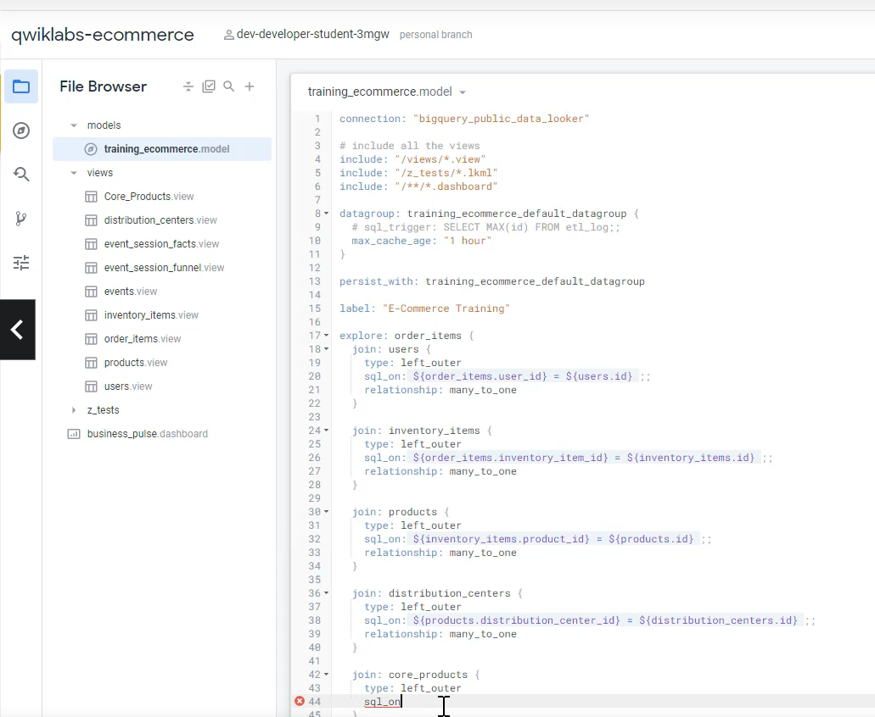 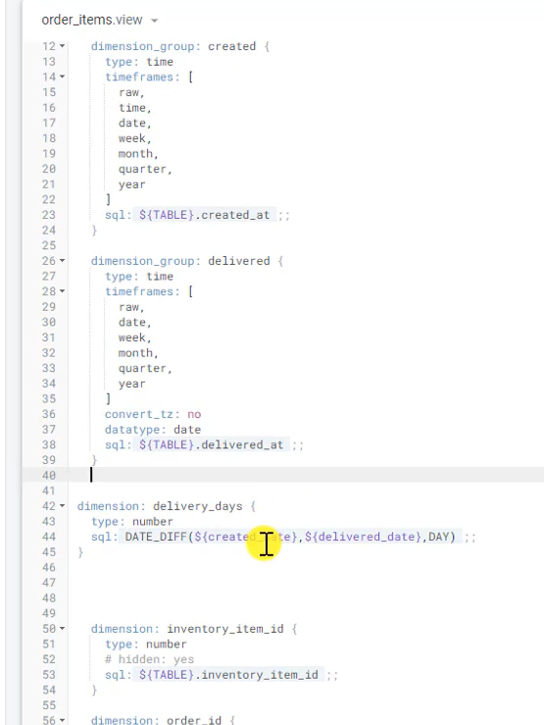

**Option:**

* Explore model helps see explore model of the model
* Commit to commit changes and push to PROD
* $Table name is reference to table used in the view

## Code reference in LookML

### **\*Apply filter for custom measure**

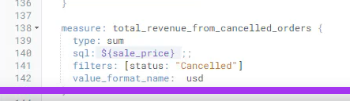

### **\*How to add calculated dimension in the view**

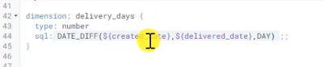

### **\*To change decimal number**

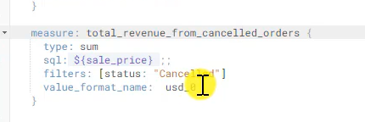 **This changes the measure to zero decimals**

### *To add default filters on model

**It should be setup on “Explore definition (ALWAYS_FILTER)**

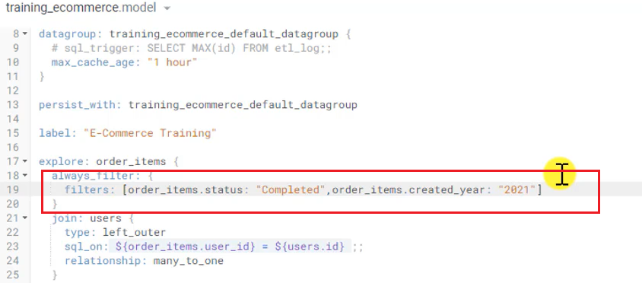

### *SQL_ALWAYS_WHERE

### * SQL_ALWAYS_HAVING

### *CONDITIONALITY_FILTER

### *Data Groups

Named caching policy that can be applied to model, view, derived tables and persistent views

### *Cache

**Develop > Projects(Specific) >**

**Data group can be setup as separate file like below (OR)**

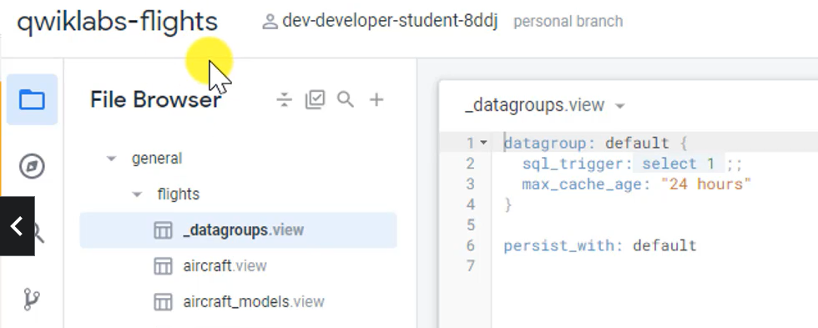

Option#2 : include in model file

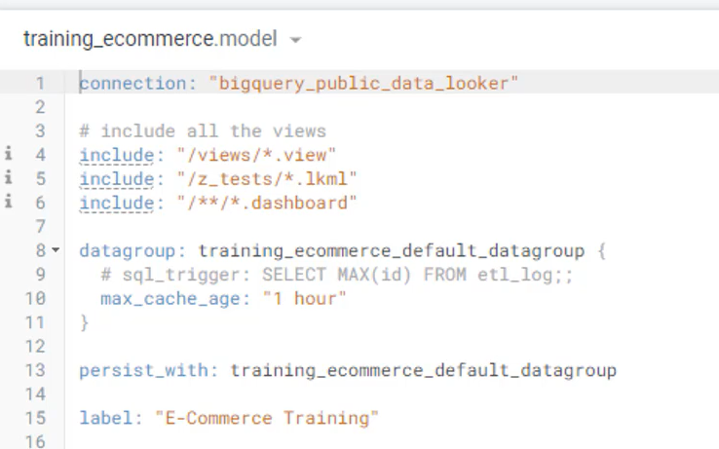

*data group has two parameters : max time that cache is valid, sql _trigger is sql triggered by explore

**\*WE NEED TO APPLY data group..just creating data group will not use it**

**Use “persist with”**

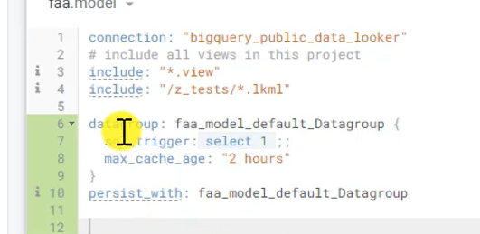

**\*We can overwrite time settings of main data group file within model..whatever used in themodel take precendence over inheritance**

**\*we can use the persist_with to just one explore within a model**

# Q &A

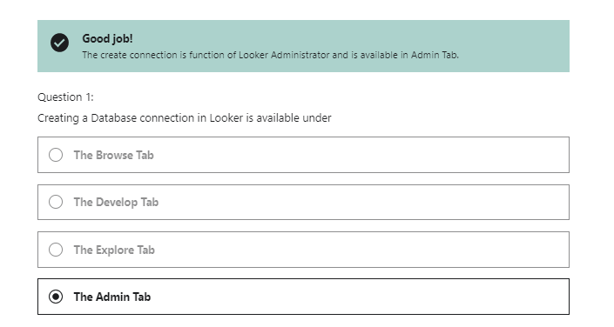

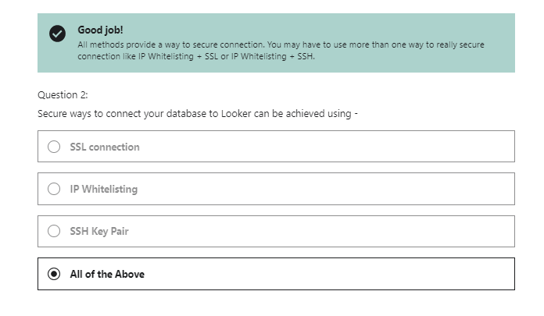

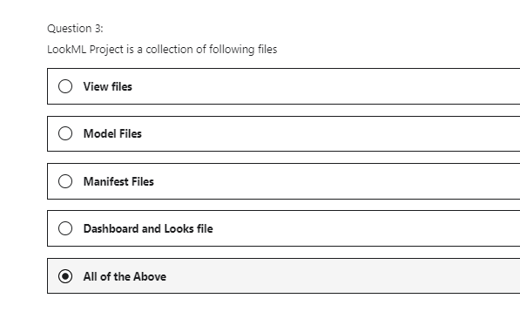

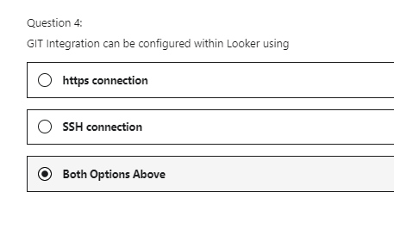

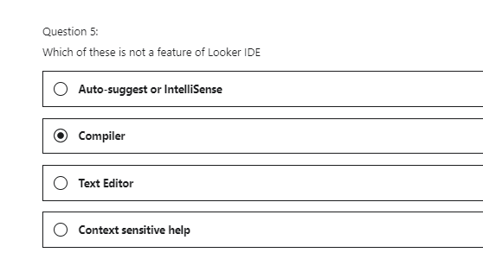

# What is/questions?

Fold

Unfold

What is rowlimit

# How to do this in Looker?

Is there any connection to unstructured database or json files? Is there cdata connector available?

How to bring disparate sources and join them?

Single data : how to use prior week and current week tile ?

Sharing looks using URL?

Can MS tools connection to send to slack or teams available?

# Features I like

End user option: Options to see underlying data while working with the graphical view

Merge results to merge results of multiple looks that are generated

# Features I hate

# Links:

**Videos tutorial:** [**https://connect.looker.com/**](https://connect.looker.com/)